(Approx. 781 words)

Power Strip Versus Surge Protector—Which Do You Need?
By Tim Elder, Treasurer, Canton Alliance Massillon User Group, OH
February 2018 issue, The Memory Map
www.camug.com
treasurer (at) camug.com

These two devices are quite similar in appearance, but they are definitely not the same. If what you need is an extension cord with multiple outlets, a power strip will work fine because it acts as an extension of the wall outlet but does not add any protection capabilities. It will have multiple outlets, probably an on-off switch, which can
disconnect all outlets at once, and maybe a circuit breaker or fuse. But if you are connecting to a computer, TV, home theater, or other electronics, a power strip will NOT be fine, because it cannot protect your expensive electronics from power line surges; for this you need a surge protector, sometimes called a surge suppressor or surge diverter.

An electrical surge is an intense very short duration voltage spike.

A surge protector does its “magic” by means of built-in electronic components which
quickly cut the power when an electrical surge comes through the mains (this is a
British term which works well for the electrical distribution grid—the system bringing
electrical power into the building) or from electric motors within the house which can
reflect surges back through the wiring. In order to work properly, a surge protector
must be connected to a grounded outlet. A surge protector will cost more than a
similar-appearing power strip.
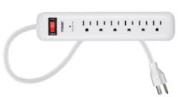
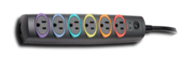

The difference in capabilities of the two devices will be found on the packaging, and on
the back of the device if the packaging has already been removed. Power strips and
surge protectors will often be placed near each other on the store shelves; so, make
sure you read the readin’ to make sure you get what you need. A surge protector is
generally, clearly labeled as such, but its capabilities can vary considerably.

Surge protectors are rated by the amount of electrical energy they can absorb, either
all at once or bit-by-bit; this will certainly be advertised on the packaging. Suggested
specifications to look for, which can be misleading if you are not paying attention,
include: 2000 joules where more is better; and, sometimes listed, response time which
is usually in nanoseconds, shorter is better.

How do you know how much of this protection is left? The number of joules is like a
reservoir, but you can’t tell how much has been used already. Thus, a surge protector
should be replaced, say, after 5 years; after this it can serve as a power strip. Since
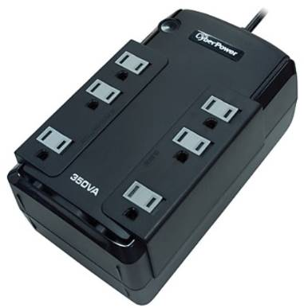
our memories are fickle, put a self-adhesive note on it saying when it was installed.
A surge protector will likely have a pilot light to tell you when the connected items are protected from line surges. If this light goes out or changes color, the surge protector
has given its life to protect whatever was connected. It will have to be replaced. But this pilot light is not foolproof, meaning that it can give false assurance.

When purchasing a surge protector, be sure to get more outlets than you think you need and remember that transformer plugs can block adjacent outlets. Also remember that a surge can come in over phone or cable wires; look for connections for these if your setup uses them.

Many surge protectors also have USB charging ports. Labeling should also include a United Laboratories seal. When I was checking the stores, the price varied from $10 to $60 depending on the number of outlets, the number of USB charging ports, and the joule capacity which ranged from 500 to 4350. The selection at Staples was much better
than at Walmart.

As with the protection pilot light, a surge protector is not foolproof, and you probably do not want to gamble with Mother Nature. If an electrical storm is approaching, you should shut down the computer, then turn off the surge protector switch or unplug it. Anytime the power goes off suddenly for any reason, your first move should be to turn off the surge protector switch to stop the risk of a surge when the power comes back on.

If you want even more protection than a surge protector offers, consider a UPS
(Uninterruptible Power Supply.) These offer a battery backup which provides a few
minutes to properly save files and shut down the computer. They can also smooth any
bumps in the incoming electrical supply; this capability is called AVR, Automatic
Voltage Regulation. A surge protector can be purchased to protect the whole house
from external surges, but these must be installed at the service entrance with the
supply disconnected. An electrician is recommended.

